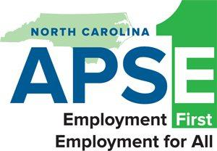
NC APSE 2026 Fall Conference
Moving Mountains, Collaborate to Elevate

Wednesday, October 14, 2026 |  |  | Thursday, October 15, 2026
 |  |  | Track Selections | Track 1  Four Seasons | Track 2  Highland
12:00pm – 1:00pm | Registration |  | 9:00am – 10:15am | Community of Practice  Courtney Horton | Statewide expansion  Work Together NC (Bridget)
1:00pm -2:30pm | KEYNOTE  Mark Anthony McGruder  Biltmore |  | 10:15am – 10:30am | Break
2:30pm -2:45pm | Break |  | 10:30am – 11:45am | Empower to Work  Sherrel Gales | Benefit Counseling –  Mark Carter
2:45pm – 4:00pm | DHB – Melanie Bush (Bridget) |  | 11:45am – 1:45pm | LUNCH Provided –  Legislative Update  Julia Adams Scheurich (Bridget)
4pm – 5pm | Networking Event |  | 1:45pm – 3:00pm | General Assembly – Presentation
Friday, October 16, 2026 |  |  | 3:00pm – 3:15pm | Break
Four Seasons Ballroom |  |  | 3:15pm – 4:30pm | Pre-ETS Post High School  Robert and Kelsey | CIE – now and the future  Claire Collagen  (Bridget)
9:00am – 11:00am | Closing Keynote  EIPD Panel  DMH Panel |  | 3:15pm – 4:30pm | Pre-ETS Post High School  Robert and Kelsey | CIE – now and the future  Claire Collagen  (Bridget)

